**Lesson 3 Demo 3**

**Understanding and Deploying First Pod**

**Objective:** To work with kubeadm

**Tools required:** kubeadm

**Prerequisites:** A Kubernetes cluster should be set up (follow the steps in Lesson 1 Demo 1)

Steps to be followed:

1. Add the given code in Firstpod.yaml
2. Create the deployment using a command
3. List the Pods available by using a command
4. Access the Apache Pod by using the given commands

**Step 1:** **Add the given code in Firstpod.yaml file**

vi Firstpod.yaml

apiVersion: v1

kind: Pod

metadata:

name: apache

labels:

Podlabel: simplilearn

spec:

containers:

- name: mycontainer

image: docker.io/httpd

ports:

- containerPort: 80

**Step 2: Create the deployment using a command**

kubectl create -f Firstpod.yaml

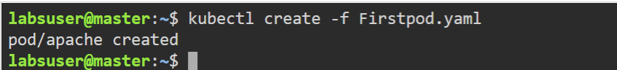

**Step 3: List the Pods available by using the following command**

kubectl get pods

**Step 4: Access the Apache Pod by using the following commands**

kubectl exec -it apache bash

